Found Quasars around PHz 631 (RA-218.4166 dec- 12.24804)

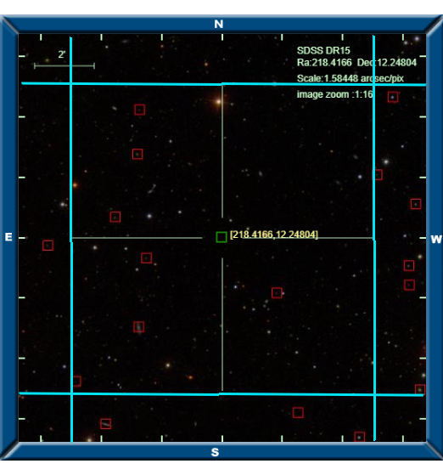

Image, blue radius around G124 is 5” from skysurver.sdss.org

|  |  |  |  |  |  |  |
| --- | --- | --- | --- | --- | --- | --- |
| **Quasar Name** | **Classification on SDSS** | **Redshift** | **RA** | **dec** | **Spectrum** | **Distance (arcmin)** |
|  |  |  |  |  |  |  |

|  |  |  |  |  |  |  |
| --- | --- | --- | --- | --- | --- | --- |
| **Star Name** | **Classification on SDSS** | **Redshift** | **RA** | **dec** | **Spectrum** | **Distance (arcmin)** |
|  |  |  |  |  |  |  |

|  |  |  |  |  |  |  |
| --- | --- | --- | --- | --- | --- | --- |
| **Qalaxy Name** | **Classification on SDSS** | **Redshift** | **RA** | **dec** | **Spectrum** | **Distance (arcmin)** |
|  |  |  |  |  |  |  |